|  |  |
| --- | --- |
| **Exercise Case** |  |
| COMP6048  Data Structures |
| Case created on Even Semester 2017/2018 | **COMP6048-SW-03** |

## Soal

*Case*

* The program consists of **3 menus**:

1. Add Initial
2. View Initial
3. Exit

* The program will ask user to **input choose menu.** Validate the input must be **between 1** and **3**

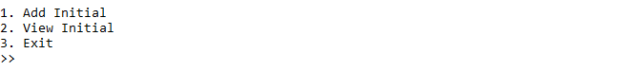

Figure 1. Screenshot for main program

* If user choose **menu 1** (**Add Initial**):
* The program will ask user to **input initial**. Validate the initial must be **follow the** **following format**

|  |
| --- |
| **XX**  X = must be **character between** **A** – **Z**  **Example valid format**:  GA, GU, HI, HN, KN, PI, RE, RR, SW, WA, WP |

* If the initial **already exists**, then **do not push the initial into the tree** and **show message** “**Initial Already Exists**”



Figure 2. Screenshot for initial already exists

* Otherwise, then **push the initial into the tree** and **show message** “**Success Add New Initial**”

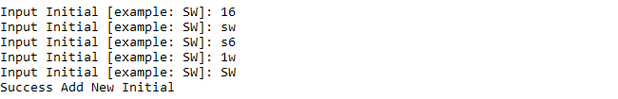

Figure 3. Screenshot for insert initial

* If user choose **menu 2** (**View Initial**):
* If there is **no initial in the tree**, then **show message** “**No Initial Available**”



Figure 4. Screenshot if there’s no initial in the tree

* Otherwise, **show all initial in the tree**

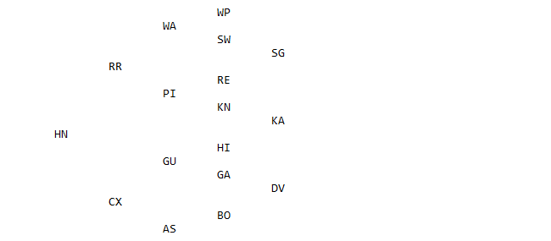

Figure 5. Screenshot for show all initial in the tree

* If user choose **menu 3** (**Exit**):
* **Delete all data from the tree** then, the program will be **closed**



Figure 6. Screenshot for exit program

Note:

* Create this program using **binary search tree concept**

**Please run the EXE file to see the sample program.**